BA$KENT 25 Student Registrar's Office

Baöhca Kampüsü Fatih Sultan Mahallesi

UNIVERSITY

1993

To Whom It May Concern,

ID NUMBER

NAME

SURNAME

REGISTRATION NUMBE

FACULTY / SCHOOL /

VOCATIONAL SCHOOL

DEPARTMENT /

PROGRAM

Eskisehir Yolu 18.km TR 06790 Ankara / TURKEY

p. +90 312 246 66 66 / 6763 f. +90 312 246 67 56 ogrisl@baskent.edu.tr

25550505850

BEYZA

KILIQDERE

21895279

FACULTY OF FINE ARTS, DESIGN AND ARCHITECTURE

PROGRAM OF FILM DESIGN



TS EN ISO 9001:2000

FORM OF REGISTRATION HIGHER EDUCATION CENTRAL EXAM

STUDENT STATUS Registered

The student attended university under a scholarship, this scholarship was given by the National Student Selection and Placement Center (ÖSYM) is attained regardless of the economic status of the student, is relevant for all programs marked with "scholarship" in the Placement Center catalogue and only comprises the

tuition fee.

This eguest of the student.

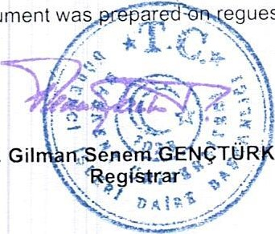

document

Prof. Dr. Gil TYR HIZAL

Number 16754223 / 304.01 /

Date 21.09.2021